DBVisualizer configuration for SQLLite

Follow the steps below to setup DBVisualizer with a SQLite Database (used by AIR) :

Download the latest SQLite jar file from http://www.zentus.com/sqlitejdbc/. On Windows drop the jar into DbVisualizer-6.5.4\jdbc\sqLite (I had to create the sqLite dir ) or in any folder you want on Mac (you can use ~/.dbvis)

The current version is v056, based on SQLite 3.6.14.2. It is attached below, but there may be a newer version on the website.

Set up the driver:
- Go to Tools menu –> Driver Manager... a new window opens
- Select Driver Menu –> Create Driver or just click the Create Driver icon.
- Enter the data as you see below.
- In the User Specified tab, click the folder and navigate to the jar file.

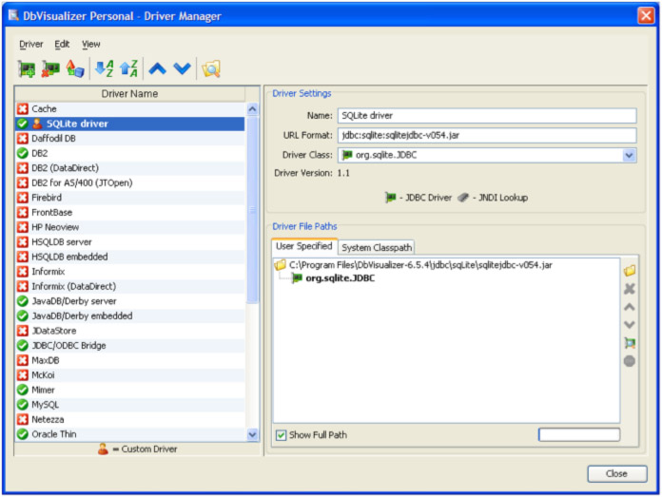

Then set up the db.

- Right click on the left panel of main window where the other db’s you have are.
- Select “Create Database Connection”.
- Select “No Wizard”
- Database alias – whatever you want to call the db.
- Data base Type: Generic
- Driver (JDBC): SQLite Driver
- Database Url: jdbc:sqlite:/Users/username/Documents/Comet/COMeT_dev.db (on Mac)
- Username : blank
- Password: blank

